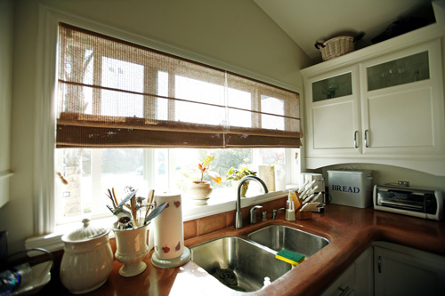

Wax to go is your “no to hair movement” best friend. It was specifically designed to be used in emergency hair removal cases where time doesn’t allow you to visit your waxing salon. The wax is packed on a small jar for a ready to go waxing session. It has no expiration and safe since it’s made from natural ingredients.

# The Wax-Abouts

SUGAR

WARM LEMON

*Citrofortunella microcarpa*

IODIZED SALT

WATER

A SPARKLE OF QUEEN BEE’S AWESOMENESS

WAX TO GO

BY: QUEEN BEE

summer 2014

# Ingredients

## The Perfect Consistency

* Wax is at an ideal consistency and temperature when it resembles a chewing gum. Heat your wax for 1 minute and let it cool a bit until it feels comfortable to be molded. Put a drop of water then mold it again.
* When the wax has gotten too sticky it’s now time to scoop for another one.

## Hair no more honey!

## Sugar Wax

is a peel off wax applied thickly on the skin and removed with your fingertips. It is used for waxing sensitive & delicate areas such as eyebrows, upper lip, facial waxing, underarms, bikini line & Brazilian waxing.  Strip Wax (Warm Wax) is applied thinly and removed with a waxing strip; this is great for larger areas of skin such as the legs, arms, back, chest and some facial waxing.

* Waxing can keep your skin hair free for up to 3-5 weeks; however results can vary with each person due to different hair types and how frequently you wax.
* is a popular depilatory method where hair is removed from the roots for longer lasting results. Wax is applied to the skin and clings to the hairs. When wax is removed, the hairs are stuck to the wax, leaving your skin smooth.  Hair regrowth becomes softer and results last longer than other forms of hair removal.

# Waxing 101

## Waxing

# Cleo’s Biscuits

*Sed metus orci, ultricies eu, vulputate quis, porttitor ut, diam. Ut tempus leo quis diam. Phasellus tempus eros eu leo. Mauris eget ante. Aliquam ornare congue augue. Integer leo.Aliquam imperdiet elit ac sem. Mauris dictum, elit in aliquet mattis, arcu nisi fringilla pede, a adipiscing elit sem in enim.*

**1 maecenas ut justo  
½ sed suscipit  
1 donec mi  
½ fusce eu nisi  
1 suspendisse**

**½ aliquam turpis odio  
½ nunc a enim**

###### Etiam tempor nibh quis tellus tempus placerat.Praesent vehicula nunc ullamcorper pede.

Nunc pulvinar elementum sem. Cras sed est. Suspendisse sed odio sed tortor nonummy tempus. Nullam urna. Quisque dictum condimentum sem. Cras nec urna blandit enim malesuada auctor. Nullam ipsum libero, cursus vitae, egestas eget, eleifend id, velit. Aenean quis ipsum sit amet purus sagittis volutpat.

Vivamus ante purus, interdum vitae, cursus quis, consectetuer sed, massa. Nulla facilisi. Donec posuere blandit pede. Nullam adipiscing fermentum turpis. Quisque nulla mauris, pretium et, egestas nec, posuere vitae, lacus. Aliquam erat volutpat. Praesent lobortis purus in ligula. Fusce et massa a nisi consectetuer fermentum. Suspendisse tempor, ipsum ac tincidunt pretium, nunc justo aliquet ante, et porta odio ipsum sed felis. Aliquam erat volutpat. Sed et tortor.

Integer varius tempus nunc. Integer et diam. Pellentesque habitant morbi tristique senectus et netus et malesuada fames ac turpis egestas. Aenean felis sapien, sagittis congue, euismod in, vestibulum quis, eros. Aliquam luctus est lacinia sem. Integer ornare urna ac lorem. Nullam viverra. Nam viverra, justo nec faucibus tincidunt, quam metus posuere pede, at bibendum ante mi vel libero.

# Vestibulum aliquam quam eget dolor. Aliquam ipsum. In euismod.

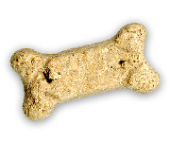

# Nunc urna lorem, gravida vel, sollicitudin in, dignissim in, nunc

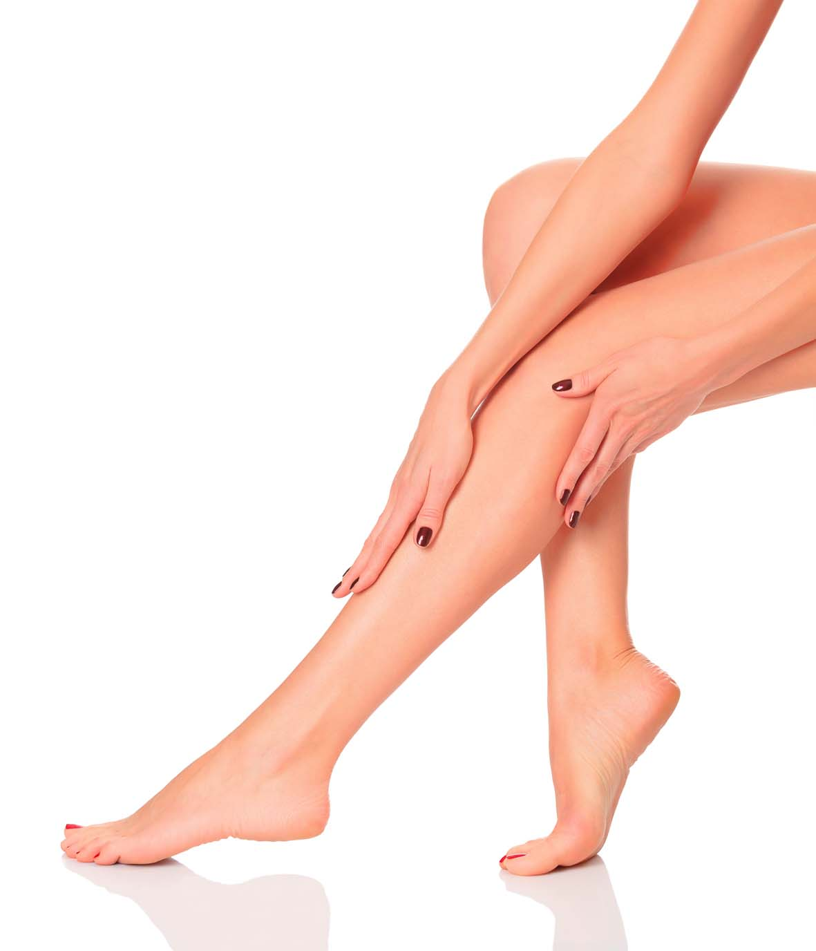

Within 4 hours of treatment

* avoid the use of make- up
* avoid hot showers or baths
* avoid swimming, sunbathing, saunas, sunbeds
* avoid deodorant

* wear loose clothing after waxing
* have a lukewarm shower on treated areas
* moisturize after showering
* gently exfoliate after 24-48 hours

THE DO’S AND THE DON’TS BEFORE AND AFTER WAXING

WAX TO GO

SUMMER 2014

WaX TO GO

ATTENTION!

The Do’s

The Don’ts